EX. NO: | SIMPLE LOGIN FORM USING REACT JS
DATE: | SIMPLE LOGIN FORM USING REACT JS

AIM:
To create a simple login form using React JS with email validation and password validation.
ALGORITHM:

STEP 1: Create a new React JS project using Vite.
STEP 2: Open the project in VS Code.
STEP 3: Create a LoginForm component.
STEP 4: Use useState() to store email, password, error messages, and login status.
STEP 5: Create input fields for email and password.
STEP 6: Validate the email format using regular expression.
STEP 7: Validate the password using the following conditions:
- Minimum 6 characters
- Starts with a capital letter
- Contains @
STEP 8: Display validation error messages if input is invalid.
STEP 9: Display login success message if validation passes.
STEP 10: Run the application using npm run dev.

PROGRAM CODE:

App.jsx
import LoginForm from "./LoginForm";

function App() {
return <LoginForm />;
}

export default App;

LoginForm.jsx
import { useState } from "react";

export default function LoginForm() {
const [email, setEmail] = useState("");
const [password, setPassword] = useState("");
const [errors, setErrors] = useState({});
const [message, setMessage] = useState("");

const validate = () => {
let err = {};

const emailPattern =
/^[^\s@]+@[^\s@]+\.[^\s@]+$/;

if (!email) {
err.email = "Email is required";
} else if (!emailPattern.test(email)) {
err.email = "Enter valid email";
}

if (!password) {
err.password = "Password is required";
} else if (password.length < 6) {
err.password = "Minimum 6 characters required";
} else if (!password.includes("@")) {
err.password = "Password must contain @";
} else if (!/^[A-Z]/.test(password)) {
err.password =
"Password must start with capital letter";
}

setErrors(err);

return Object.keys(err).length === 0;
};

const handleSubmit = (e) => {
e.preventDefault();

if (validate()) {
setMessage("Login Successful ✅");
} else {
setMessage("");
}
};

return (
<div style={styles.container}>
<div style={styles.card}>
<h2>Login Form</h2>

<form onSubmit={handleSubmit}>
<input
type="text"
placeholder="Enter Email"
style={styles.input}
value={email}
onChange={(e) =>
setEmail(e.target.value)
}
/>

{errors.email && (
<p style={styles.error}>
{errors.email}
</p>
)}

<input
type="password"
placeholder="Enter Password"
style={styles.input}
value={password}
onChange={(e) =>
setPassword(e.target.value)
}
/>

{errors.password && (
<p style={styles.error}>
{errors.password}
</p>
)}

<button type="submit" style={styles.button}>
Login
</button>
</form>

<p style={styles.message}>{message}</p>
</div>
</div>
);
}

const styles = {
container: {
height: "100vh",
display: "flex",
justifyContent: "center",
alignItems: "center",
background:
"linear-gradient(135deg, #4facfe, #00f2fe)"
},

card: {
background: "white",
padding: "35px",
borderRadius: "15px",
width: "320px",
boxShadow:
"0 0 15px rgba(0,0,0,0.2)",
textAlign: "center"
},

input: {
width: "100%",
padding: "12px",
marginTop: "12px",
borderRadius: "8px",
border: "1px solid #ccc",
outline: "none"
},

button: {
width: "100%",
padding: "12px",
marginTop: "15px",
background: "#4facfe",
color: "white",
border: "none",
borderRadius: "8px",
cursor: "pointer",
fontSize: "16px"
},

error: {
color: "red",
fontSize: "13px",
textAlign: "left",
marginTop: "5px"
},

message: {
marginTop: "15px",
fontWeight: "bold",
color: "green"
}
};

main.jsx
import { StrictMode } from 'react'
import { createRoot } from 'react-dom/client'
import './index.css'
import App from './App.jsx'

createRoot(document.getElementById('root')).render(
<StrictMode>
<App />
</StrictMode>,
)

OUTPUT:

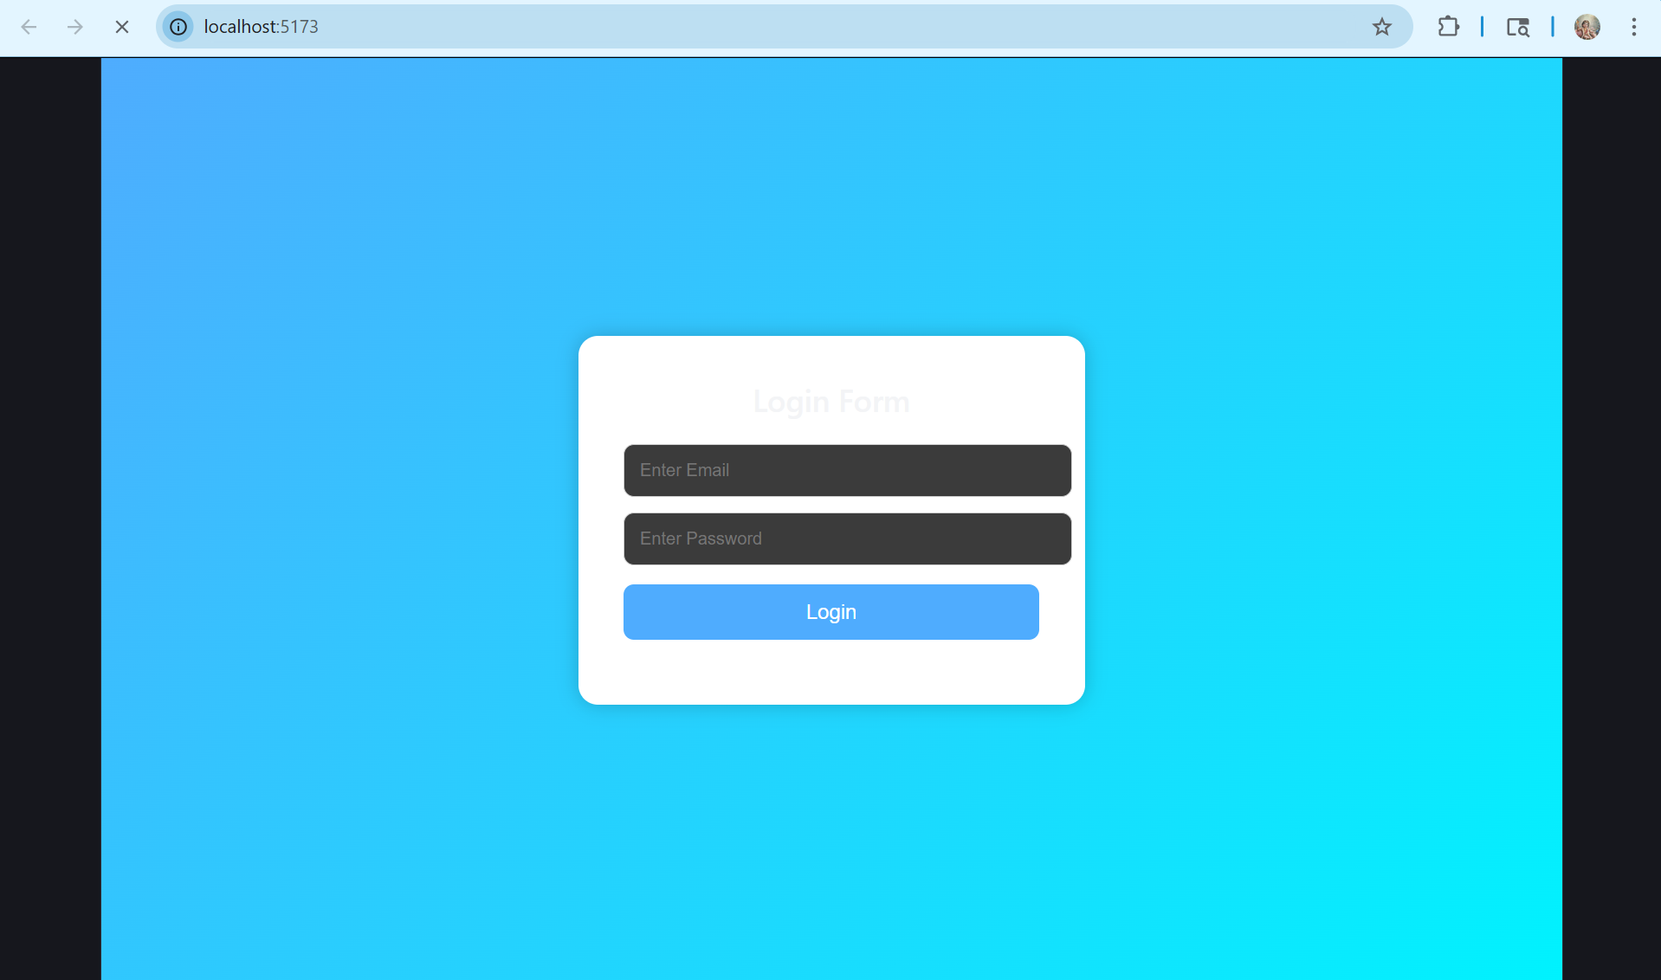

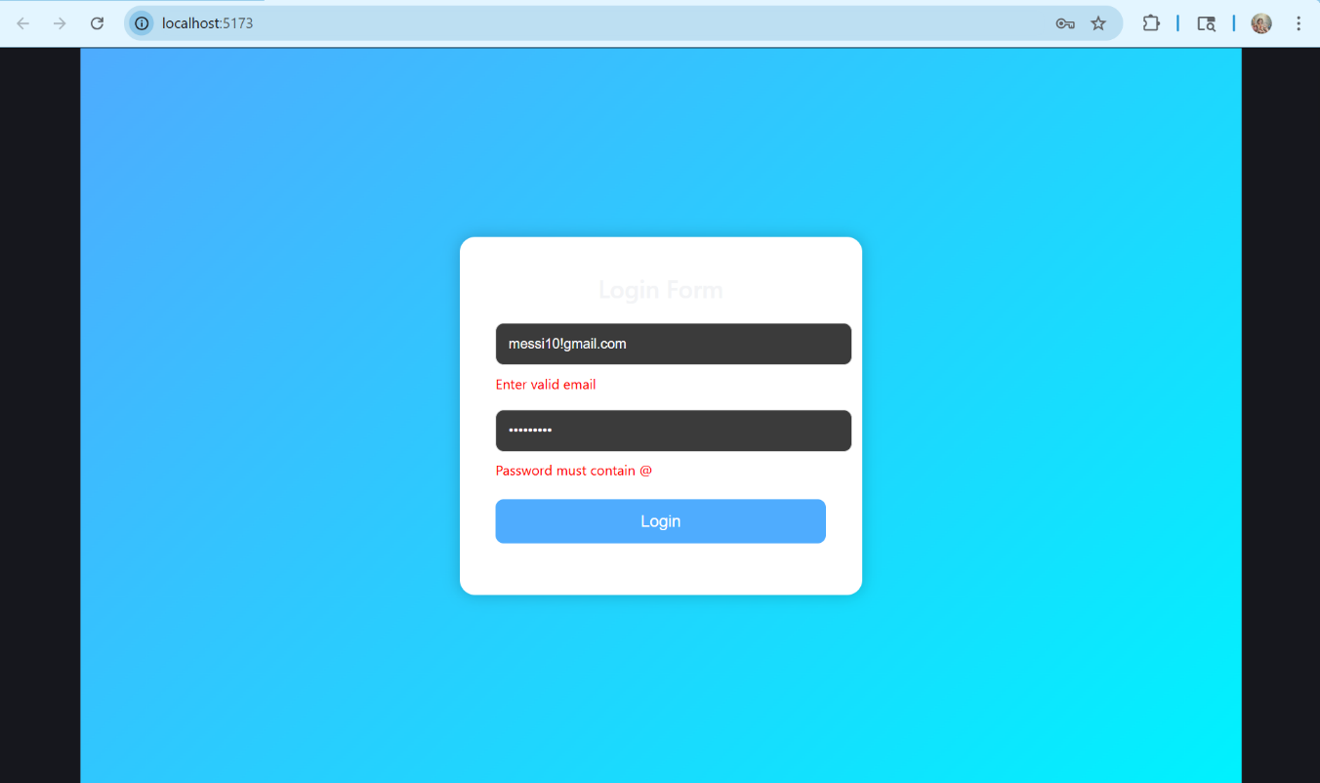

RESULT:
Thus, the simple login form using React JS with email validation and password validation was created and executed successfully.

